**Assignment 2: Practice with Single Row Functions**

In this assignment, you'll get practice applying everything you learned about single row functions.

Review the CITY table structure shown below and answer the questions that follow.

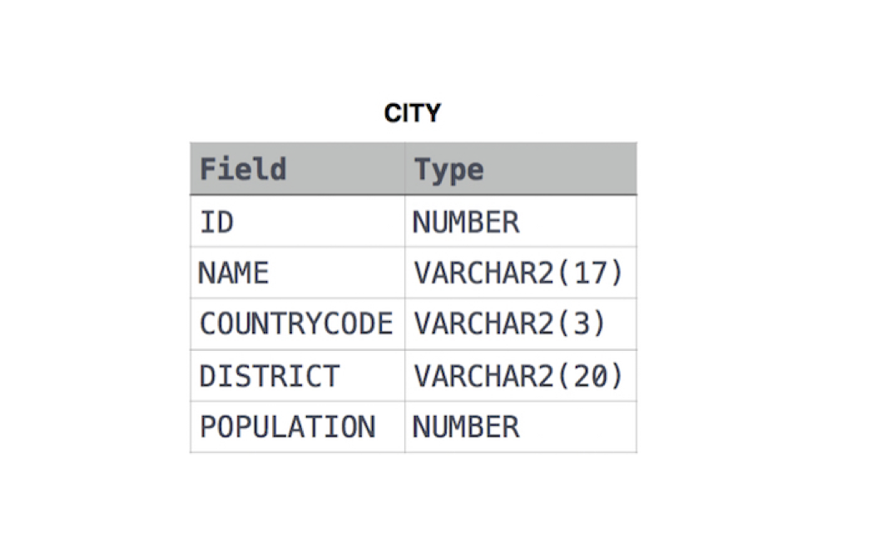

**Questions for this assignment**

1. *Considering the data exists in the city table, write a query that will return records similar to what is shown below for those cities that have the COUNTRYCODE of 'cbd' :*

"NEW YORK CITY has the population of 8,500,000"

"LOS ANGELES has the population of 632,000"

*Note: I'd like you to use functions in the SELECT statement to solve this problem.*

1. *Write a query that would show the first three letters and the last three letters of the DISTRICT capitalized and separated by a dash.*

*Note: I'd like you to use functions in the SELECT statement to solve this problem.*

1. *Review the following SQL statement:*

**SELECT MONTHS_BETWEEN(LAST_DAY('15-JAN-12') + 1, '01-APR-12') FROM DUAL;**

Considering the database is configured for the given date format, what will be the result of executing the query?

1. *TRUE or FALSE Question:*

Giving the date arguments in chronological order to the MONTHS_BETWEEN function will result in an error.

1. *Which of the following is true regarding character functions?*

A). They always accept characters as parameters and nothing else.

B). They always return a character value.

C). They are generally used to process text data.

D). They generally have the letters CHAR somewhere in the function name.

1. *Which of the following is true regarding functions in SQL?*

A). They never return a value.

B). They often return a value.

C). They always return a value.

D). There is no consistent answer to whether they return a value or not.

1. *Review the SQL Statement:*

**SELECT SUBSTR('2009', 1, 2) || LTRIM('1124', '1') FROM DUAL;**

*What will be the result of executing the SQL Statement?*

A). 2024

B). 221

C). 20124

D). A syntax error

1. *TRUE or FALSE Question:*

Review the syntax of how the NULLIF function is used:

**NULLIF( expr1, expr2 )**

*The NULLIF function returns expr1 if expr1 and expr2 are not equal.*

1. *TRUE or FALSE Question:*

The **TO_CHAR** function converts data from various data types to character data. It can accept characters, a number or a date as valid arguments.

**\*Do not scroll past here without trying out the assignment yourself\***

**Instructor Solutions for this assignment**

1. *Considering the data exists in the city table, write a query that will return records similar to what is shown below for those cities that have the COUNTRYCODE of 'cbd' :*

"NEW YORK CITY has the population of 8,500,000"

"LOS ANGELES has the population of 632,000"

*Note: I'd like you to use functions in the SELECT statement to solve this problem.*

**SELECT CONCAT(CONCAT(UPPER(name), ' has the population of '), population)**

**FROM city**

**WHERE LOWER(countrycode) = 'cbd';**

1. *Write a query that would show the first three letters and the last three letters of the DISTRICT capitalized and separated by a dash.*

*Note: I'd like you to use functions in the SELECT statement to solve this problem.*

**SELECT CONCAT(CONCAT(UPPER(SUBSTR(district, 1, 3)), ' - '),**

**UPPER(SUBSTR(district, LENGTH(district) - 2)))**

**FROM city;**

1. *Review the following SQL statement:*

**SELECT MONTHS_BETWEEN(LAST_DAY('15-JAN-12') + 1, '01-APR-12') FROM DUAL;**

Considering the database is configured for the given date format, what will be the result of executing the query?

**-2**

*The reason -2 will be returned is that the LAST_DAY function will transform the value of '15-JAN-12' TO '31-JAN-12' and then the result of that will be added to 1. So the first argument of the MONTHS_BETWEEN function ends up being '01-FEB-12'. Difference between the 2 dates results in a -2.*

1. *TRUE or FALSE Question:*

Giving the date arguments in chronological order to the MONTHS_BETWEEN function will result in an error.

**FALSE.**

*You may give the 2 dates in any order you please. If the dates are in chronological order, the result will be a negative number. If the dates are in reverse chronological order, the answer will be a positive number.*

1. *Which of the following is true regarding character functions?*

A). They always accept characters as parameters and nothing else.

B). They always return a character value.

C). They are generally used to process text data.

D). They generally have the letters CHAR somewhere in the function name.

**Answer: C**

1. *Which of the following is true regarding functions in SQL?*

A). They never return a value.

B). They often return a value.

C). They always return a value.

D). There is no consistent answer to whether they return a value or not.

**Answer: C**

1. *Review the SQL Statement:*

**SELECT SUBSTR('2009', 1, 2) || LTRIM('1124', '1') FROM DUAL;**

*What will be the result of executing the SQL Statement?*

A). 2024

B). 221

C). 20124

D). A syntax error

**Answer: A**

1. *TRUE or FALSE Question:*

Review the syntax of how the NULLIF function is used:

**NULLIF( expr1, expr2 )**

*The NULLIF function returns expr1 if expr1 and expr2 are not equal.*

**TRUE**

1. *TRUE or FALSE Question:*

The **TO_CHAR** function converts data from various data types to character data. It can accept characters, a number or a date as valid arguments.

**TRUE**